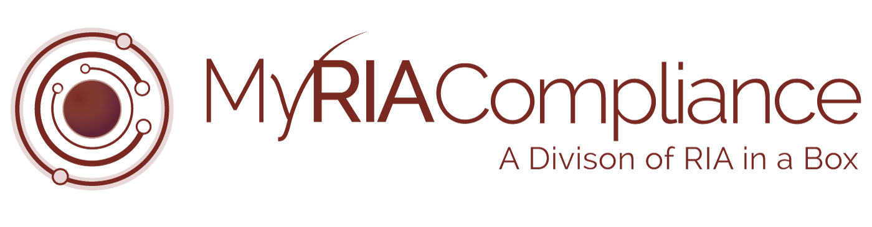*The following document is provided to You as a sample only.  Prior to using or implementing this document or any portion thereof, You should tailor the contents, including any highlighted sections, to fit your specific situation and should consult relevant regulatory authorities and/or legal counsel. RIA in a Box and its compliance division (“We”) do not represent or warrant that the contents of the document are suitable for You from a compliance, regulatory, legal, or any other perspective. We shall have no responsibility or liability for your use or non-use of the document or any portion thereof. We are not law firms, investment advisory firms, or CPA firms and do not provide legal advice or opinions.* ***Please note that reference to “FIRM” should be changed to reference your firm name or the firm’s abbreviation used in other portions of your compliance manual.***

Copyright © 2018 RIA in a Box LLC

*FIRM may discuss and display, charts, graphs, formulas which are not intended to be used by themselves to determine which securities to buy or sell, or when to buy or sell them. Such charts and graphs offer limited information and should not be used on their own to make investment decisions.*